Evan Wilson / Nicholas Thomas

CST-235

September 2nd, 2018

Instructor: Dr. Toure

CLC Mini Project 7

Green Group

Question 1: Research programmableweb.com and identify one web service written in Java. Explain its use with a code example.

The web service example I found on programmableweb.com running on Java was Zepher SOAP Web Services API for Java. Zephyr is listed as the world’s most widely used software test management solution (Alexander, 2018). They implement advanced quality assurance (QA), automation and analytics tools for software development. The Zepher SOAP Web Services API integrates Zephyr’s services including dashboards and tests into the Java environment (Programmableweb.com, 2018). Below is a testcase example listed on programmableweb.com:

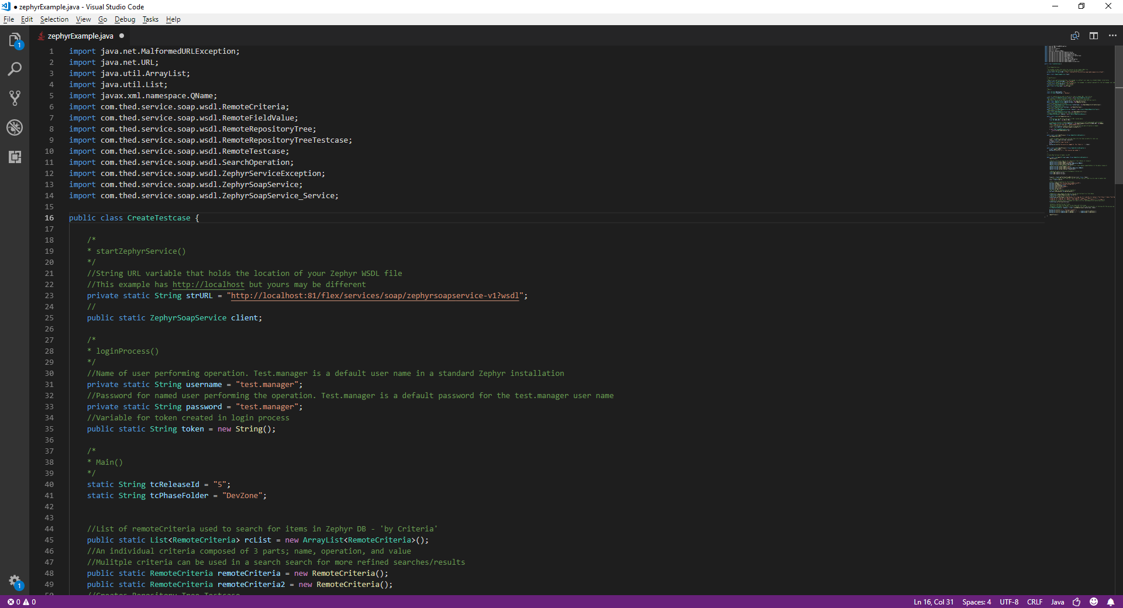

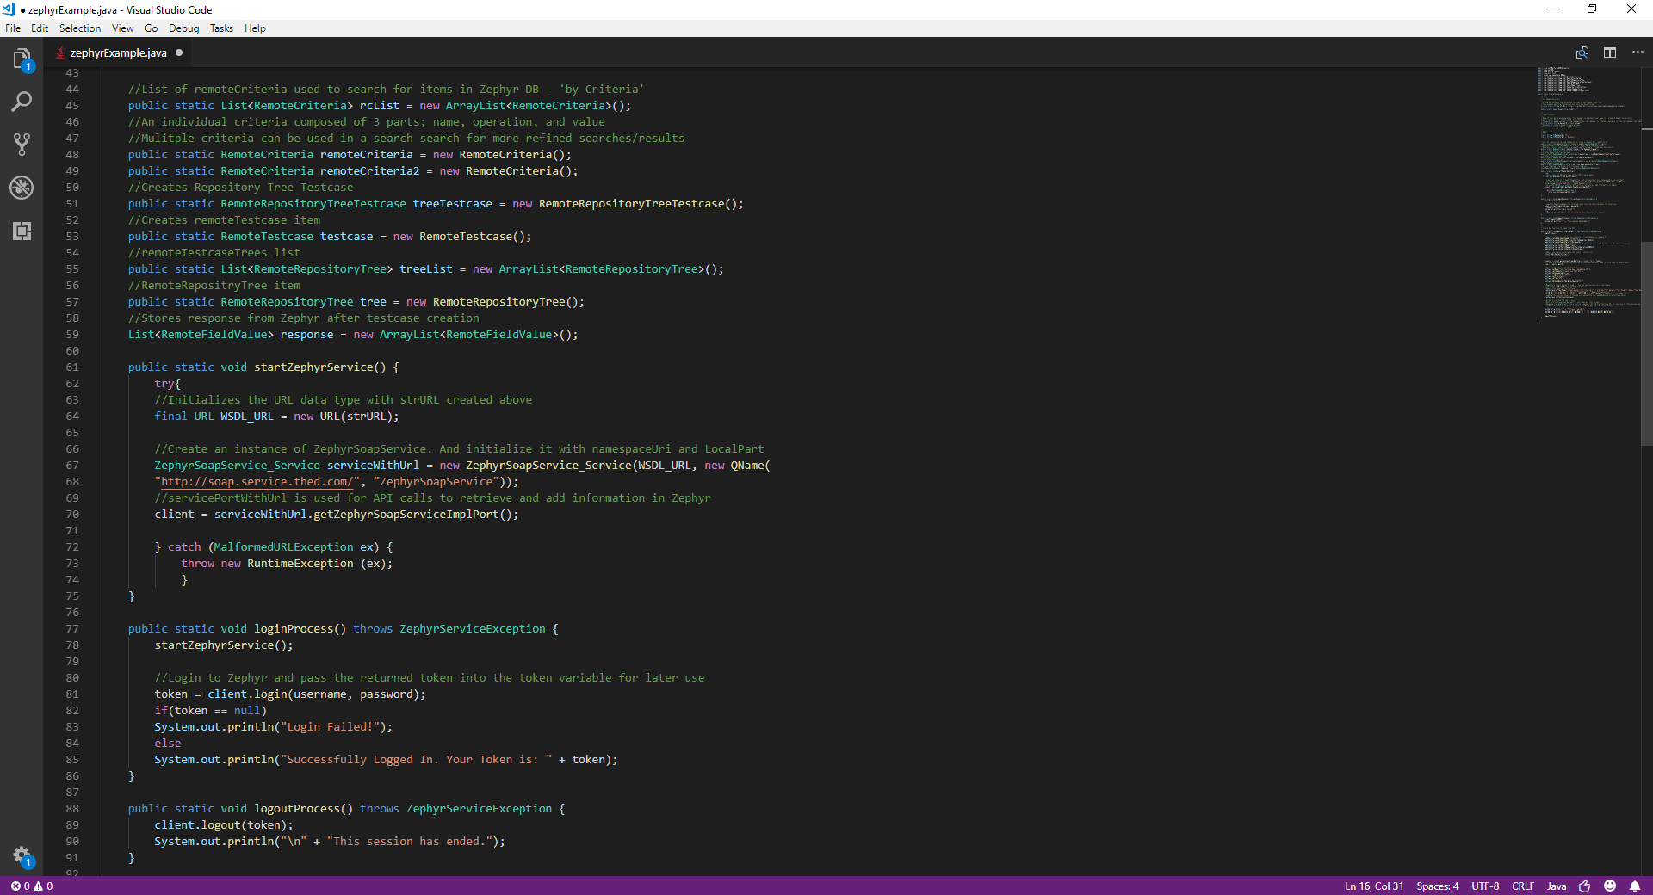

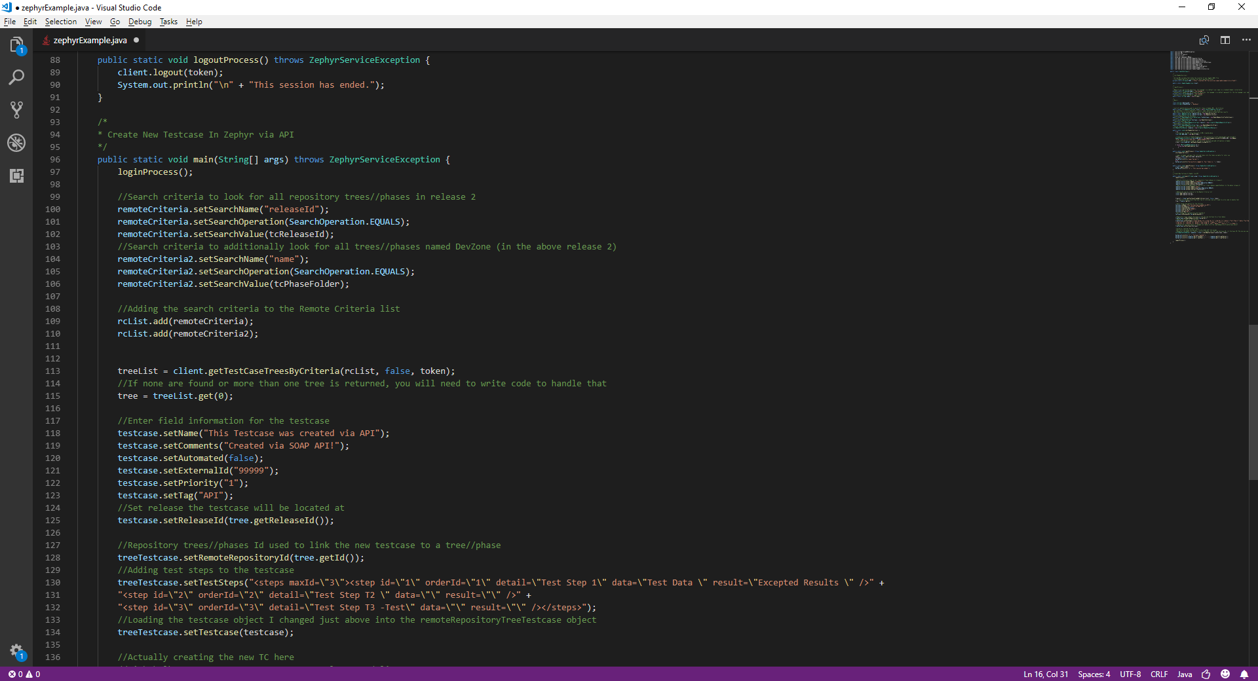

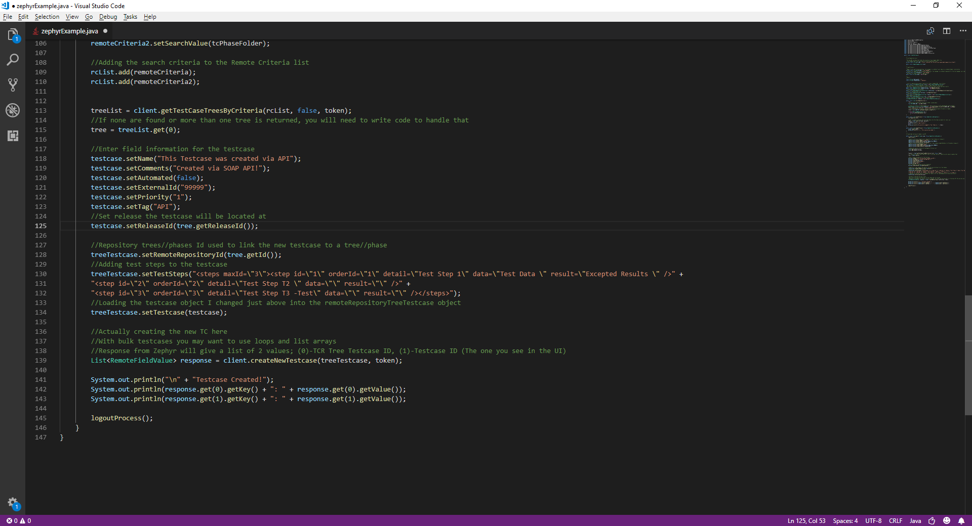

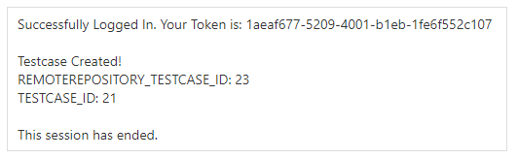

# References

Alexander, T. (2018, September 6). *Zephyr 6.2 Accelerates Software Testing and Advances Collaboration for Agile Teams*. Retrieved from Zephyr: https://www.getzephyr.com/buzz/press-releases/zephyr-62-accelerates-software-testing-and-advances-collaboration-agile-teams?hellobar=true

ProgrammableWeb. (2018, March 13). *Zephyr SOAP Web Services Sample Code*. Retrieved from ProgrammableWeb.com: https://www.programmableweb.com/sample-source-code/zephyr-soap-web-services-java-sample-code

Zephyr. (2015, November 12). *Getting Started with Zephyr SOAP API for JAVA*. Retrieved from atlassian.net: https://zephyrdocs.atlassian.net/wiki/spaces/DEVELOPER/pages/33095748/Getting+Started+with+Zephyr+SOAP+API+for+JAVA